News and Information in COVID 19 situation

Date | Subject | Paper/Source | Links/Attachments
01.06.2020 | Have Covid-19 Lockdown and Raging Summer Made a Dent in Progress We Made to Curb Water Crisis? | News 18 | https://www.news18.com/news/mission-paani/have-covid-19-lockdown-and-raging-summer-made-a-dent-in-progress-we-made-to-curb-water-crisis-2646719.html
30.05.2020 | Guidelines of extended lockdown | Government Order | https://www.mha.gov.in/sites/default/files/MHADOLrDt_3052020.pdf
30.05.2020 | Announcement of Lockdown extension | Government Order | https://www.mha.gov.in/sites/default/files/MHAOrderDt_30052020.pdf
26.05.2020 | Hit by cyclone Amphan, villages in Sunderbans face drinking water crisis | Hindustan Times | https://www.hindustantimes.com/india-news/hit-by-cyclone-amphan-villages-in-sunderbans-face-drinking-water-crisis/story-ggOH1uq5rBIowJPaLfstlM.html
23.05.2020 | Cyclone 'Amphan': Protests across Kolkata as power, water crisis continues | Times of India | https://timesofindia.indiatimes.com/city/kolkata/cyclone-amphan-protests-across-kolkata-as-power-water-crisis-continues/articleshow/75918222.cms
17.05.2020 | 560 migrant workers in Bihar found Covid-19 positive | Times of India | https://timesofindia.indiatimes.com/city/patna/560-migrant-workers-in-bihar-found-covid-19-positive/articleshow/75787605.cms
16.05.2020 | Coronavirus chaos to worsen water crisis in Delhi | India Today | https://www.indiatoday.in/mail-today/story/coronavirus-chaos-to-worsen-water-crisis-in-delhi-1678595-2020-05-16
15.05.2020 | Finance Minister Nirmala Sitharaman announces Rs 1 lakh crore fund to develop agri infrastructure. | Asian News International (ANI) | https://aninews.in/news/national/general-news/sitharaman-announces-rs-1-lakh-crore-fund-to-develop-agri-infrastructure20200515175423/
14.05.2020 | Finance Minister announces short term and long-term measures for supporting the poor, including migrants, farmers, tiny businesses and street vendors | Press Information Bureau (PIB) | https://pib.gov.in/PressReleasePage.aspx?PRID=1623862
12.05.2020 | COVID-19 Lockdown: 50% of stranded migrant labourers have less than Rs 100; 97% didn't get cash transfer from govt, finds report | First Post | https://www.firstpost.com/health/covid-19-lockdown-50-of-stranded-migrant-labourers-have-less-than-rs-100-97-didnt-get-cash-transfer-from-govt-finds-report-8359701.html
12.05.2020 | COVID-19: Migrant workers from West Bengal, Bihar protest in Jaipur | The Hindu | https://www.thehindu.com/news/national/other-states/covid-19-migrant-workers-from-west-bengal-bihar-protest-in-jaipur/article31564245.ece
08.05.2020 | COVID-19 in India: 16 migrant workers run over by train | Anadolu Agency | https://www.aa.com.tr/en/asia-pacific/covid-19-in-india-16-migrant-workers-run-over-by-train/1833389
08.05.2020 | COVID-19 shows ugly plight of migrant workers | Deccan herald | https://www.deccanherald.com/opinion/panorama/covid-19-shows-ugly-plight-of-migrant-workers-835078.html
05.05.2020 | Sharp Rise In Coronavirus Containment Zones In Bengal, Most Are In Kolkata | NDTV | https://www.ndtv.com/india-news/coronavirus-sharp-rise-in-coronavirus-containment-zones-in-bengal-most-are-in-kolkata-2223347
05.05.2020 | Covid-19: Migrant workers protest across India, demand to be sent back home | Business Standard | https://www.business-standard.com/article/current-affairs/migrant-crisis-deepens-protests-erupt-demanding-to-be-sent-back-home-120050500158_1.html
30.04.2020 | Categorization of areas based on Red, Orange and Green zones | The Hindu | https://www.thehindu.com/news/resources/article31478595.ece/BINARY/Ltr%20to%20CS%2030%20april.pdf.pdf
29.04.2020 | Order on movement of Migrant workers, students, pilgrims, tourists and other persons | Ministry of Home Affairs | https://www.mha.gov.in/sites/default/files/MHAordernew_29042020.PDF
26.04.2020 | Centre rushes in to junk IRS officers' report proposing wealth tax; CBDT orders inquiry | India Today | https://www.indiatoday.in/india/story/centre-rushes-in-to-junk-irs-officers-report-proposing-wealth-tax-cbdt-orders-inquiry-1671411-2020-04-26
26.04.2020 | Coronavirus Crisis: No lockdown for domestic violence | Decan Herald | https://www.deccanherald.com/specials/insight/coronavirus-crisis-no-lockdown-for-domestic-violence-829941.html
26.04.2020 | Domestic violence during Covid-19 lockdown emerges as serious concern | Hindustan Times | https://www.hindustantimes.com/india-news/domestic-violence-during-covid-19-lockdown-emerges-as-serious-concern/story-mMRq3NnnFvOehgLOOPpe8J.html
25.04.2020 | India's migrant workers fall through cracks in COVID-19 lockdown | MoneyControl India | https://www.moneycontrol.com/news/india/coronavirus-pandemic-indias-migrant-workers-fall-through-cracks-in-covid-19-lockdown-5189241.html
23.04.2020 | Lockdown in India has impacted 40 million internal migrants: World Bank | The Economics Times | https://economictimes.indiatimes.com/news/politics-and-nation/lockdown-in-india-has-impacted-40-million-internal-migrants-world-bank/articleshow/75311966.cms?from=mdr
22.04.2020 | Starvation, Police Beatings and Covid-19: For Migrant Workers Stuck in Delhi | News 18 India | https://www.news18.com/news/india/starvation-police-beatings-and-covid-19-for-migrant-workers-stuck-in-delhi-the-choices-are-stark-2588163.html
20.04.2020 | Union Home Ministry issues guidelines for movement of migrant labourers within State | The Hindu | https://www.thehindu.com/news/national/coronavirus-lockdown-e-commerce-firms-cant-supply-non-essential-goods-says-indian-government/article31380752.ece
19.04.2020 | COVID-19 crisis: India needs a plan to help migrant workers | Financial Express | https://www.financialexpress.com/opinion/covid-19-crisis-india-needs-a-plan-to-help-migrant-workers/1932718/
19.04.2020 | Order for movement of Migrant workers within state by Ministry of Home Affairs | Government Order | No. 40-3/2020-DM_I (A) dated 19th April, 2020
17.04.2020 | New Delhi State Government shifted 1500 migrant labourers from Yamuna bank to shelters | Times of India | https://timesofindia.indiatimes.com/city/delhi/1500-migrant-workers-shifted-from-yamuna-bank-to-shelters/articleshow/75190141.cms?utm_source=twitter.com&utm_medium=social&utm_campaign=TOIDesktop
15.04.2020 | Order for providing supplementary nutrition to children and pregnant mother by Aganwadi Workers | Government Order | No.camp 06/ICDM-Dte Dated 15th April 2020
15.04.2020 | Women domestic workers struggling for basic necessities | News 18 India | https://www.news18.com/news/india/modiji-please-help-karo-women-domestic-workers-struggling-for-basic-necessities-during-covid-19-lockdown-2578117.html
15.04.2020 | Covid-19 and the water crisis in India: a wakeup call for clean water | Smart Water Magazine | https://smartwatermagazine.com/news/smart-water-magazine/covid-19-and-water-crisis-india-a-wakeup-call-clean-water
14.04.2020 | Will Covid-19 force India to face up to its water crisis? | The Third pole | https://www.thethirdpole.net/en/2020/04/14/will-covid-19-force-india-to-face-up-to-its-water-crisis/
12.04.2020 | Order for taking possible measures for saving people from COVID-19 by GoWB | Government Order | Order No 79-CS/2020 dated 12-04-2020
11.04.2020 | Life in containment zone tough for residents of rural areas, slums | The Hindu | https://www.thehindu.com/news/cities/Delhi/life-in-containment-zone-tough-for-residents-of-rural-areas-slums/article31314891.ece
10.04.2020 | Institutions offer emotional support to youngsters | The Hindu | https://www.thehindu.com/news/national/other-states/institutions-offer-emotional-support-to-youngsters/article31313094.ece
10.04.2020 | Migrant workers and daily wagers are at greatest risk | The Hindu | https://www.thehindu.com/opinion/op-ed/charting-a-common-minimum-relief-programme/article31268751.ece
10.04.2020 | Food delivery man (Dabbawalas) have lost their livelihood | The Hindu | https://www.thehindu.com/news/cities/mumbai/coronavirus-lockdown-robs-mumbais-dabbawalas-of-lunch/article31303907.ece
09.04.2020 | Domestic violence during lockdown | The Hindu | https://www.thehindu.com/opinion/op-ed/no-lockdown-for-abuse/article31292334.ece
09.04.2020 | Impending water crisis may be bigger problem than Covid-19: Hyderabad activist | Times of India | https://timesofindia.indiatimes.com/city/hyderabad/impending-water-crisis-may-be-bigger-problem-than-covid-19-activist/articleshow/75055604.cms
08.04.2020 | Govt. mulls lockdown extension amid requests from state | The Hindu | https://www.thehindu.com/news/national/morning-digest-april-8-2020/article31285515.ece
08.04.2020 | Industrial workers faced with widespread hunger | The Hindu | https://www.thehindu.com/news/cities/kolkata/industrial-workers-faced-with-widespread-hunger/article31293457.ece
08.04.2020 | Do letter by NITI aayog during COVID 19 lockdown | Government Order | DO No. Al/Misc 2020-Admin-II Dated-08-04-2020
07.04.2020 | Prolong Lockdown adversely affect food security | The Hindu | https://www.thehindu.com/opinion/op-ed/farmers-are-at-their-wits-end/article31273857.ece
07.04.2020 | Handwashing helps stop COVID-19. But in India, water is scarce | MSN News | https://www.msn.com/en-in/news/in-depth/handwashing-helps-stop-covid-19-but-in-india-water-is-scarce/ar-BB12iqh0
06.04.2020 | Increase of Corona cases due to TablighiJamaat event | The Hindu | https://www.thehindu.com/news/national/coronavirus-number-of-cases-doubled-in-41-days-in-india-due-to-tablighi-jamaat-event-says-government/article31262700.ece
03.04.2020 | Daily wagers migrated to cities facing misery | The Hindu | https://www.thehindu.com/news/national/andhra-pradesh/with-no-help-from-companies-migrant-workers-out-in-the-cold/article31243560.ece
02.04.2020 | Rise in domestic violence; The National Commission for Women | The Hindu | https://www.thehindu.com/news/national/covid-19-lockdown-spike-in-domestic-violence-says-ncw/article31238659.ece
31.03.2020 | Migrant workers gathers outside a bus station in Ghaziabad | The Hindu | https://www.thehindu.com/opinion/op-ed/locking-down-two-different-indias/article31210743.ece?homepage=true
31.03.2020 | Migrant sprayed with Chemicals in UP | The Telegraph | https://www.telegraphindia.com/india/migrants-sprayed-with-chemical-in-bareilly-town/cid/1760720
31.03.2020 | Food demand by Migrants in Kerala | The Telegraph | https://www.telegraphindia.com/india/coronavirus-lockdown-migrants-demand-food-test/cid/1760650
31.03.2020 | Virus non-medical fallout: 2cr jobs uncertain | The Telegraph | https://www.telegraphindia.com/india/virus-non-medical-fallout-2cr-jobs-uncertain-ostracism-mistrust-and-widening-class-divide/cid/1760663?ref=more-from-india_india-page
30.03.2020 | Migrant labours have been walking hundreds of kilometers | The Hindu | https://www.thehindu.com/news/national/other-states/coronavirus-an-unending-journey-to-their-homes/article31211955.ece?homepage=true
30.03.2020 | Announcement for establishing nodal Covid facilitate Hospitals | News 18 | https://www.news18.com/news/india/bengal-cm-mamata-banerjee-announces-nodal-covid-19-hospitals-in-all-22-districts-2557591.html
30.03.2020 | Obtaining databases of the workers across the country who are leaving for their home states | The Telegraph | https://www.telegraphindia.com/states/west-bengal/coronavirus-lockdown-bengal-to-collect-worker-data/cid/1760396
29.03.2020 | Lockdown Leaves Vast Numbers Stranded and Hungry | The New York Times | https://www.nytimes.com/2020/03/29/world/asia/coronavirus-india-migrants.html
24.03.2020 | Announcement of Finance Minister on relief measures on COVID-19dt, 24.03.2020. | pib.gov.in | https://pib.gov.in/PressReleaseIframePage.aspx?PRID=1607942

DO No. Al/Misc 2020-Admin-II Dated-08-04-2020
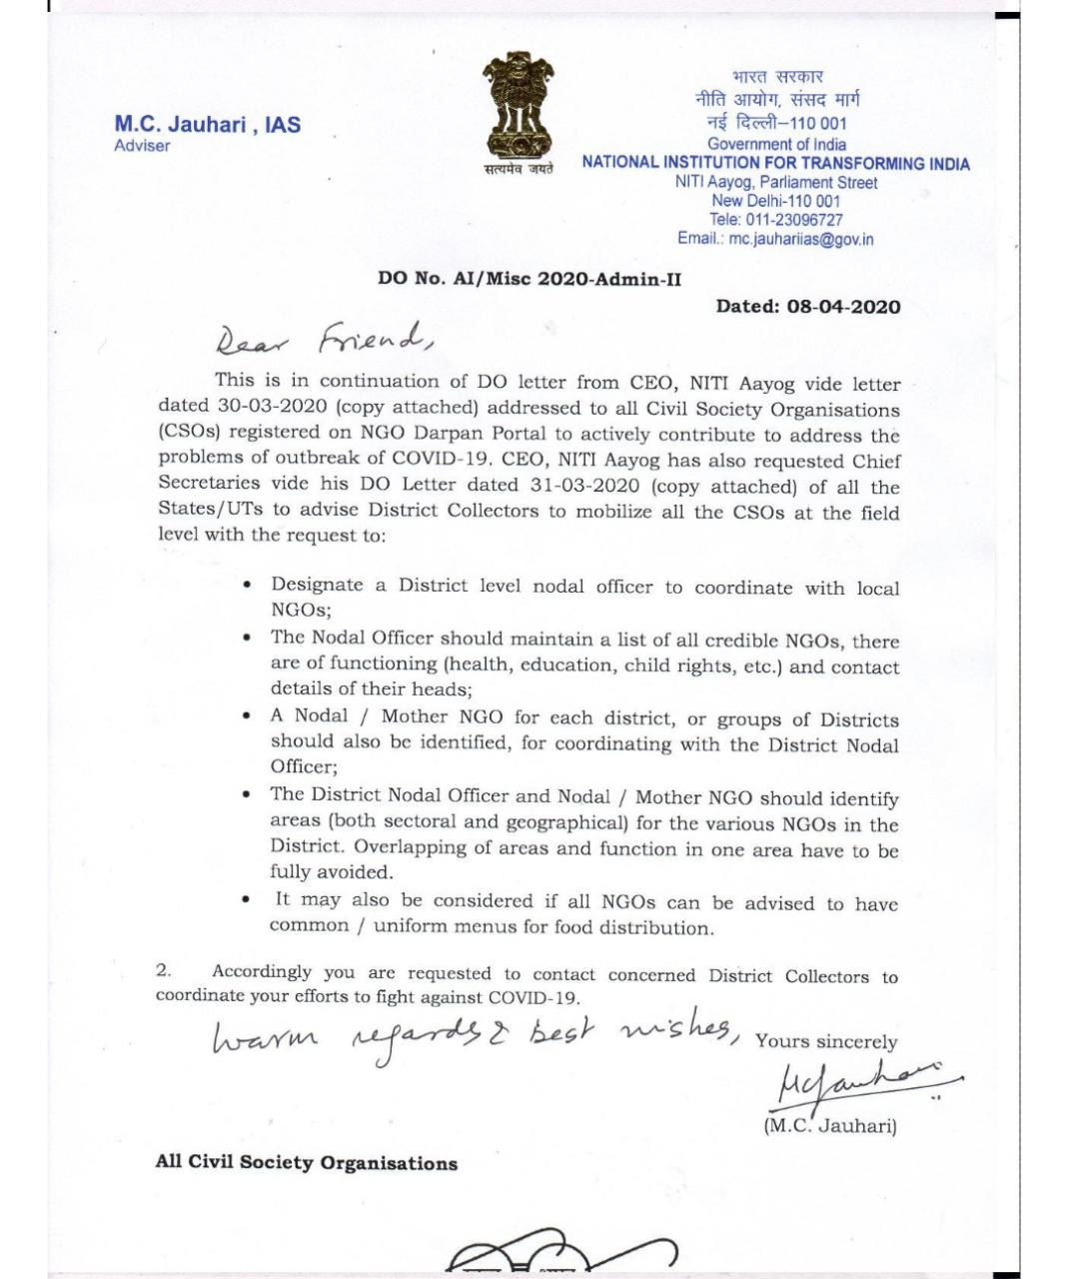

Order No 79-CS/2020 dated 12-04-2020
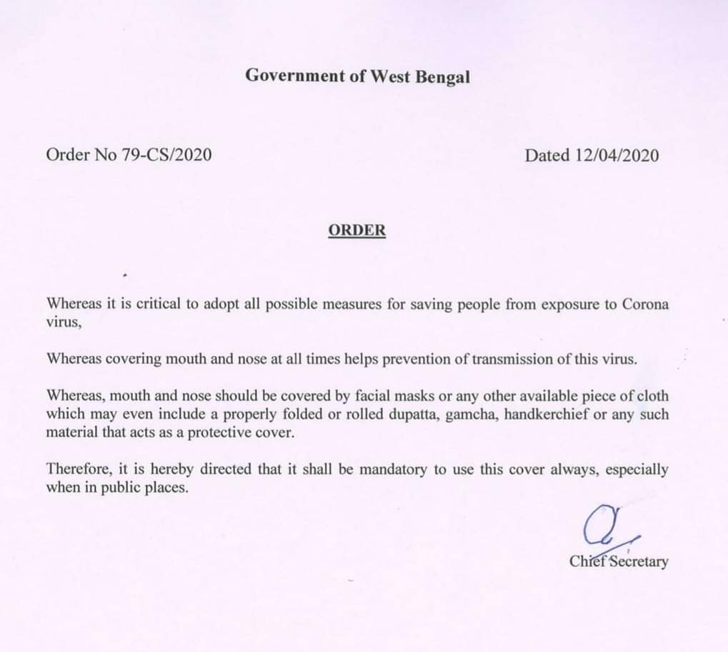

No.camp 06/ICDM-Dte Dated 15th April 2020
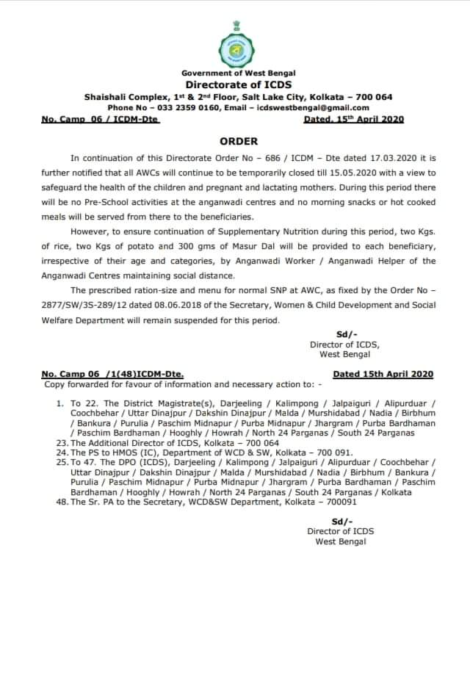

No. 40-3/2020-DM_I (A) dated 19th April, 2020
